Inserting a Hyperlink into PowerPoint
- Find your research on the Internet.
- Click and highlight the URL in the web address bar

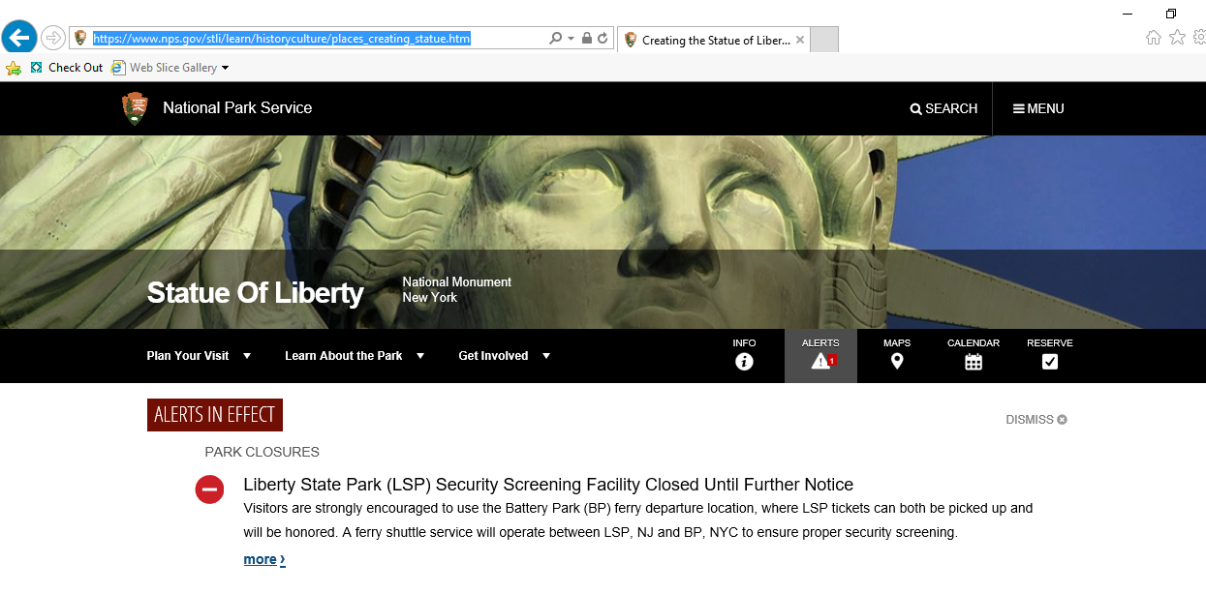
- Right click the web address and click copy
- Open up your PowerPoint presentation to the slide in which you are going to hyperlink your information and type the information on the slide. 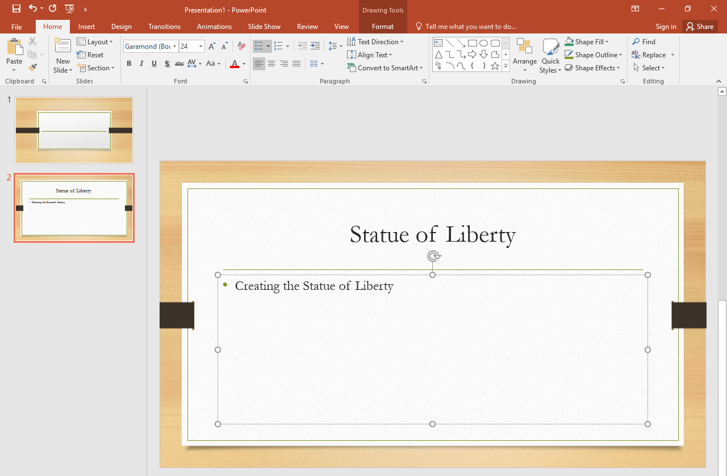
- Highlight the word(s) you want to hyperlink. 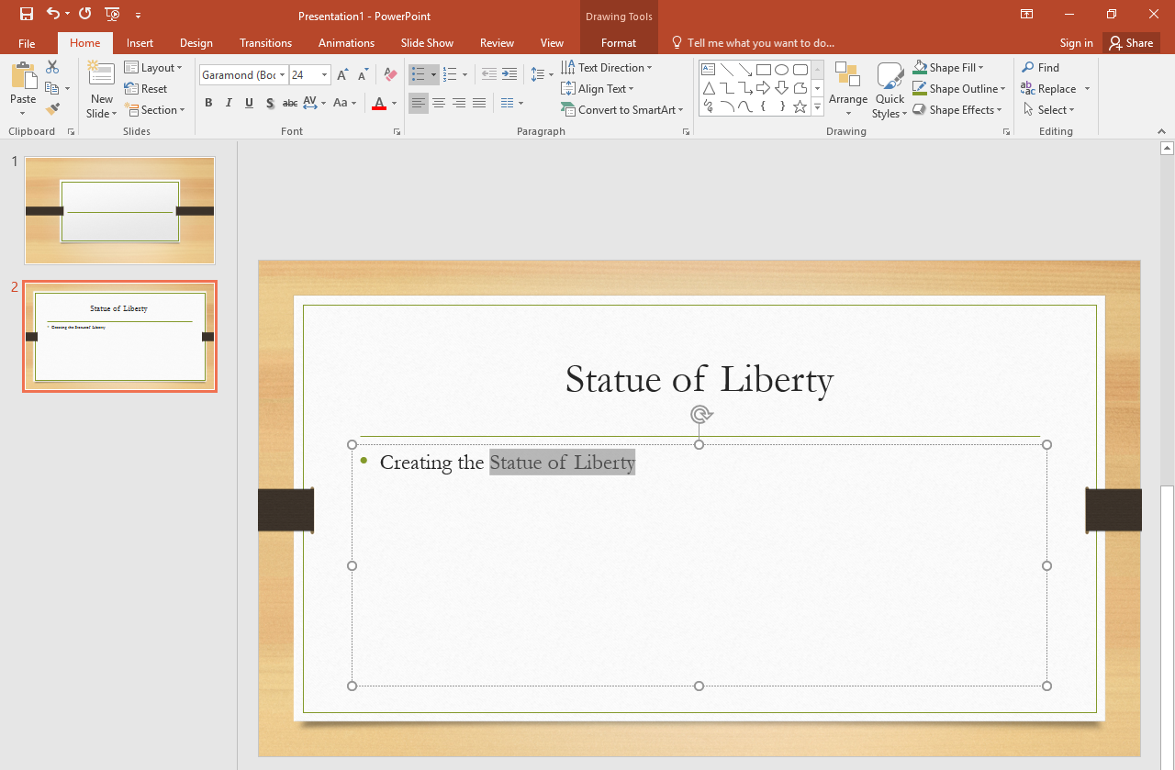
- Click the “Insert” tab at the top, then click “Hyperlink” 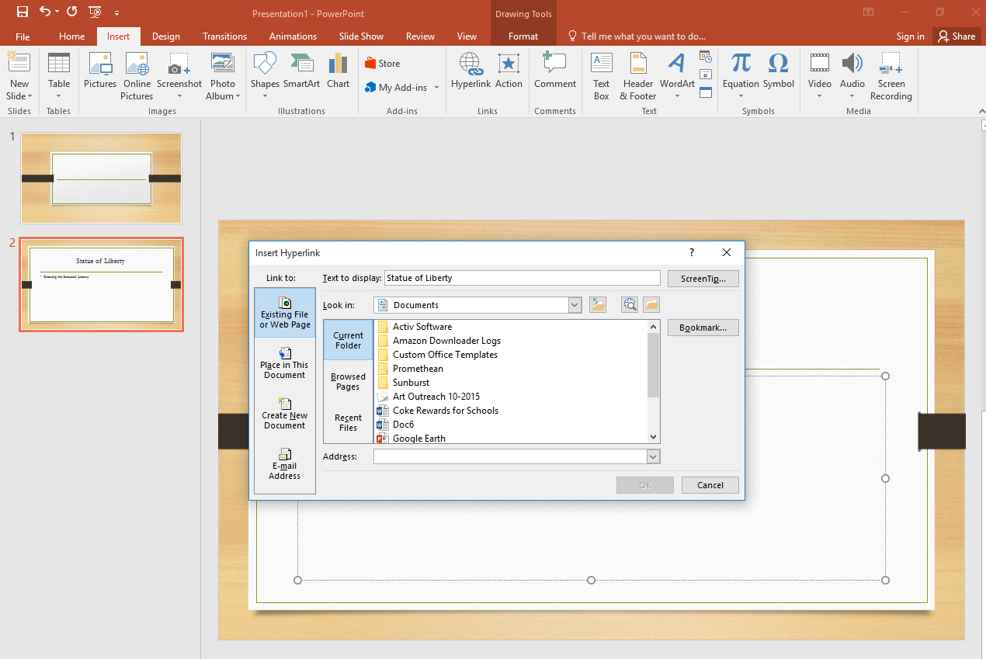
- Paste the URL address that you copied from the webpage in the address bar then press ok.
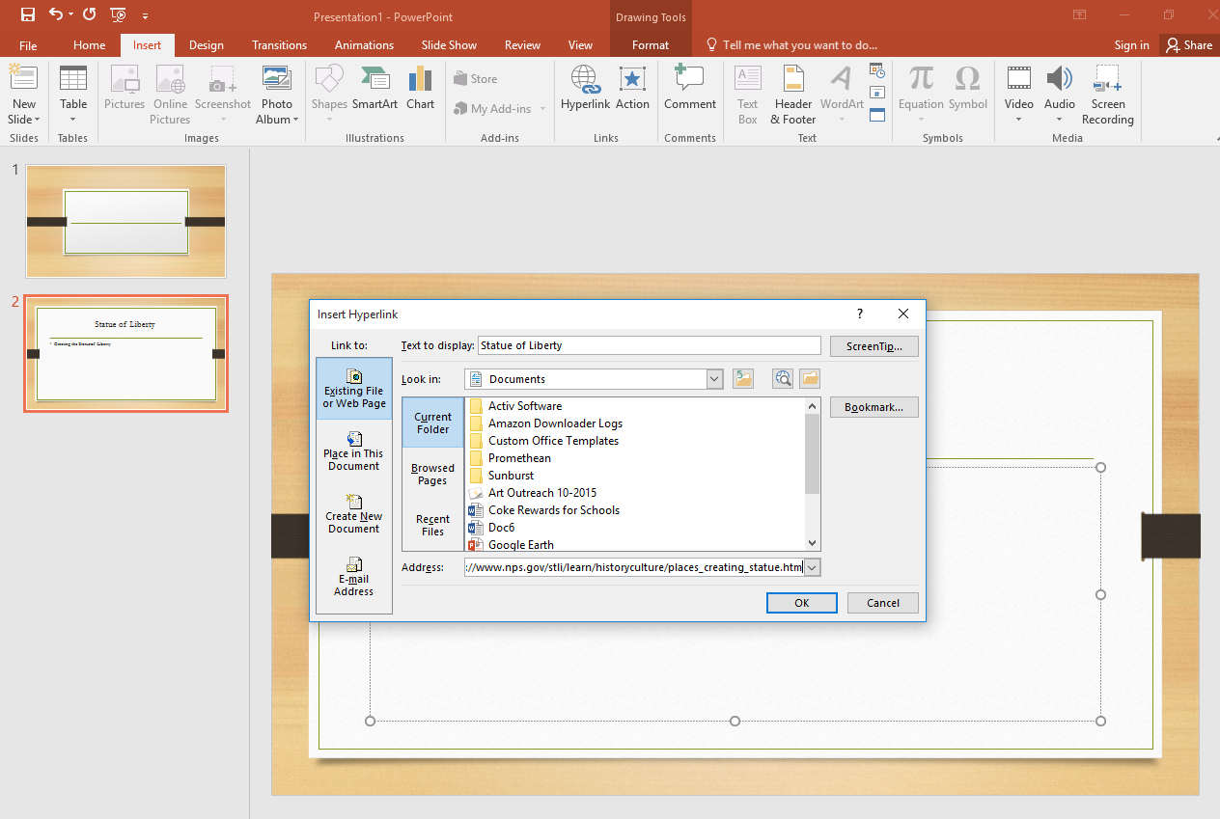
- The word(s) you highlighted will now be hyperlinked.
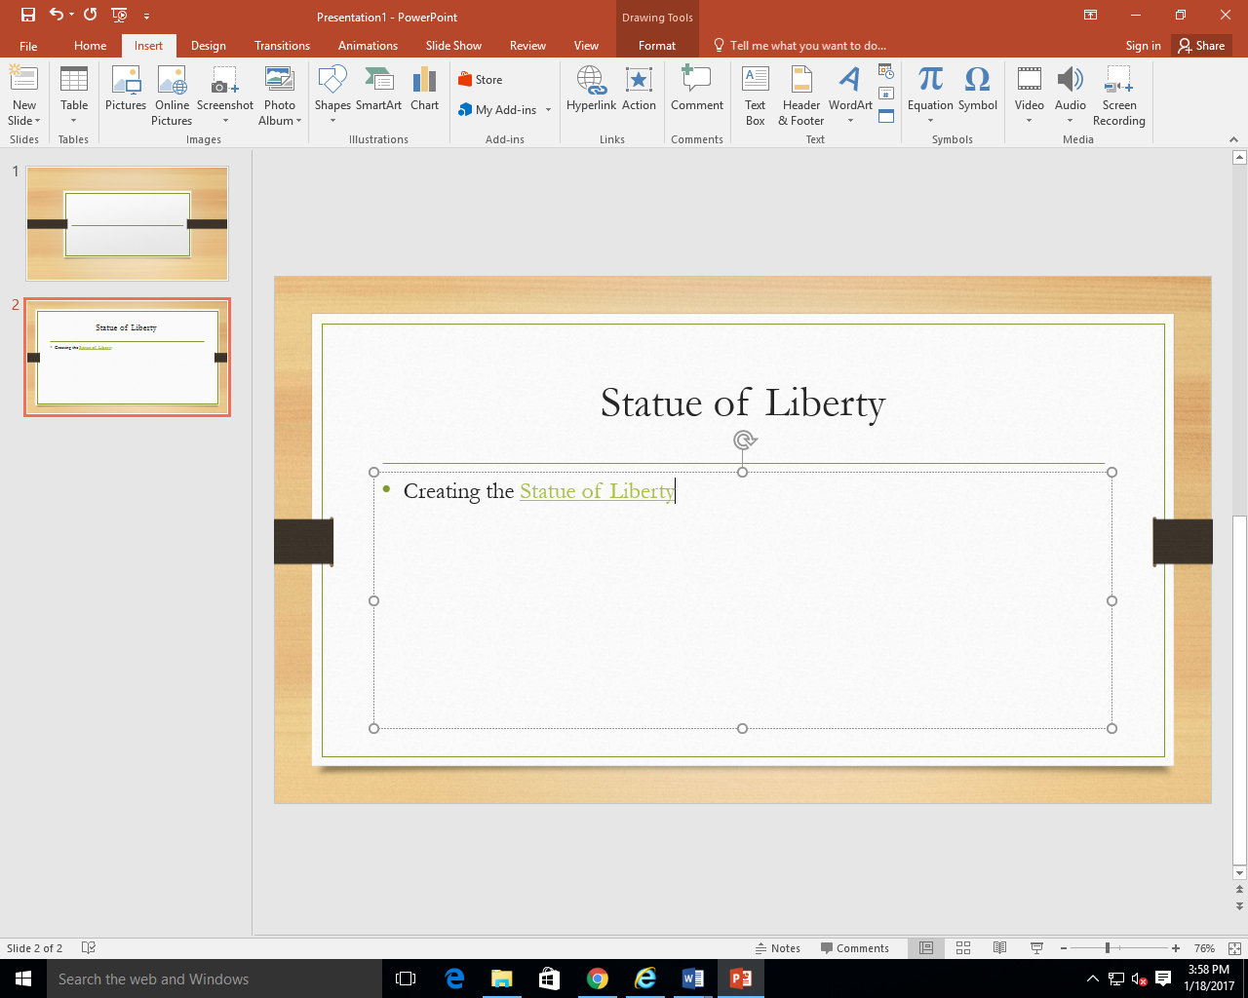
- You can test/view the hyperlink in presentation mode.

