Technology Standards Articulation by Grade
Third Grade

STRAND 1: Basic Computer Operations and Concepts

Every student will understand the operation and function of technology and become proficient in its use.
Concept 1: Communicate about technology using appropriate and accurate terminology.
Students will:

B 1. Identify and use basic computer components, including input and output devices (e.g. mouse, monitor, keyboard, storage devices, cursor, printer, headphones, microphone, digital camera)

B 2. Use basic appropriate technology vocabulary (e.g. desktop, monitor, keyboard, mouse, start, logoff, print, click and double-click, backspace, delete, maximize, minimize, icons, taskbar, open and close)

B 3. Use applications, folders, hard drive, recycle bin, network folder, document icons

B 4. Recognize the purpose of basic file menu options (e.g. new, open, save, save as, quit, exit, print, print preview, undo, redo etc.)

Concept 2: Computer Access
Students will:

B 1. Power on/power off computer

B 2. Login/logout of computer/network

B 3. Demonstrate proper use/handling of computer drives and peripherals

B 4. Open and quit an application

Concept 3: Input Devices
Students will:

B 1. Navigate with a pointing device (e.g. use of drop down menus, use of vertical and horizontal scrolling, ability to choose options within a program)

B 2. Use left-click mouse function

B 3. Use double-click mouse function

B 4. Use right-click mouse function

Concept 4: Computer Navigation
Students will:

B 1. Locate, launch and exit software applications using icons or shortcuts that are appropriate for the designed task (e.g. local and network)

Technology Standards Articulation
Third Grade

B 2. Use file management to create, locate and save files from local and network drives

B 3. Navigate with assistance using browser, address bar, refresh, forward, back, URL, stop, home, search, link, etc.

B 4. Open and use multiple programs, windows, and/or browser tools simultaneously

Concept 5: Output Devices
Students will:

B 1. Print independently choosing printer (e.g. local, network, color, etc.), quality, number of pages, format)
Concept 6: Media Resources
Students will:

B 1. Use an interactive white board

Concept 7: Troubleshoot Systems and Applications
Students will:

B 1. Apply strategies for identifying and solving routine frozen screens that occur in everyday use.

B 2. Select technology tools and software to solve problems

B 3. Perform undo/redo function

B 4. Use guess and check strategies

2

Technology Standards Articulation
Third Grade

STRAND 2: Digital Citizenship

Students understand human, cultural and societal issues related to technology and practice legal, ethical and moral behavior.
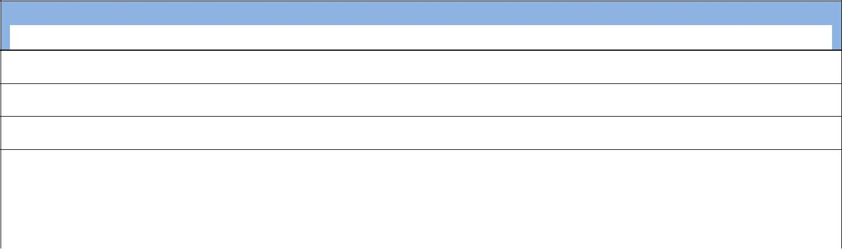
Concept 1: Develop Positive Technology-Related Behaviors and Attitudes
Students will:

B 1. Follow directions when using computers and peripherals

B 2. Work collaboratively with others

B 3. Assist others when needed

B 4. Complete tasks as assigned

B 5. Respect the rights of others

B 6. Recognize how technology is used in today’s world

Concept 2: Acceptable Use
Students will:

B 1. Use school network and Internet ethically and appropriately

B 2. Demonstrate appropriate behaviors when using technology (e.g. Internet, Cell Phone)

B 3. Handle external media carefully (e.g. cd, dvd etc.)

B 4. Demonstrate correct and responsible use and care of technology

B 5. Discuss and follow school’s Acceptable Use Policy (AUP)

B 6. Acknowledge ownership of created works

Concept 3: Internet Personal Safety
Students will:

B 1. Recognize and understand responsible cyber-community citizenship (e.g. Club Penguin and Webkinz, or similar websites)

B 2. Understand and practice responsible use of personal safety (e.g. password, personal and family information)

B 3. Recognize and understand the use of technology as a way to communicate with others and access information for learning

B 4. Develop an understanding of proper netiquette when communicating with others online

B 5. Develop positive attitudes and understand cyber-bullying

3

Technology Standards Articulation
Third Grade

STRAND 3: Technology Tools that Promote Creativity and Innovation

Every student will demonstrate creative thinking, construct knowledge and develop innovative products and processes using technology.

Concept 1: Experience a variety of software and online applications to complete innovative products and processes.
Students will:

B 1. Use appropriate software application(s) to complete tasks (e.g. Kid Pix, Paint, Word Processing)

Concept 2: Keyboarding
Students will:

B 1. Locate, identify and use A-Z and 0-9 keys

B 2. Locate special keys (e.g. enter, spacebar, escape, tab key, arrow keys, shift, caps lock, num lock, delete and backspace keys)

B 3. Locate and utilize keyboard shortcuts (e.g. Esc, Ctrl, Alt, and Del )

B 4. Use correct home row hand positions, fingering and posture
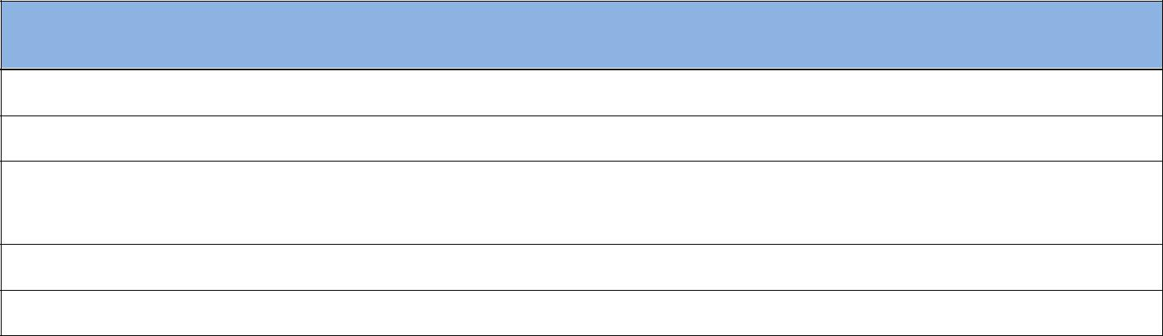

Concept 3: Word Processing
Students will:

B 1. Use basic word processing skills to enhance the writing process

B 2. Use clip art to illustrate concepts and ideas

B 3. Identify, locate and practice terms and concepts related to word processing (e.g. toolbars, alignment, font style, font size, font color, etc.)

B 4. Use word processing skills to format text, (e.g. centering, spell check, thesaurus)

B 5. Be able to open, create, delete, copy, paste, save, locate and/or print a file/document

Concept 4: Skill Building with Spreadsheets
Students will:

B 1. Identify and define terms and concepts related to spreadsheets (e.g. sort, row, column, cell address, etc.)

B 2. Enter data into cells of spreadsheet program

4

Technology Standards Articulation
Third Grade
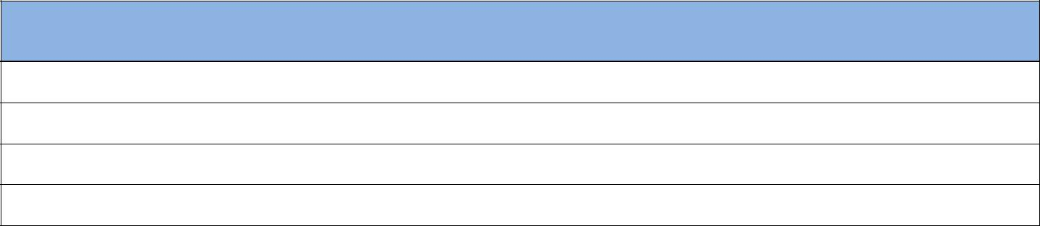

Concept 5: Multimedia
Students will:

B 1. Identify and define terms and concepts related to multimedia (e.g. transition, slides)

B 2. Utilize draw / paint software, to create original works

B 3. Locate, import and adjust graphics to enhance original works of self-expression

B 4. Introduce basic skills to create a slide show presentation
Concept 6: Transfer Current Knowledge to Learning of New Technologies
Students will:

B 1. Use concepts and basic skills and apply them to more advanced software.
Concept 7: Skill Building with Desktop Publishing
Students will:

Introduced in Grade 4

5

Technology Standards Articulation
Third Grade

STRAND 4: Communication & Collaboration

Every student will use productivity tools and will collaborate, publish and interact with peers, experts and other audiences by using telecommunications and media

Concept 1: Communication
Students will:

B 1. Use digital media to gain understanding of cultural differences in a global society with teacher guidance

B 2. Use various digital media to communicate and exchange ideas

Concept 2: Collaboration
Students will:

B 1. Collaborate with others using digital media to learn, develop and share information or create a project in a curriculum area

6

Technology Standards Articulation
Third Grade

STRAND 5: Technology Research Tools

Every student will utilize technology based research tools to locate and collect information pertinent to the task, as well as evaluate and analyze information from a variety of sources.
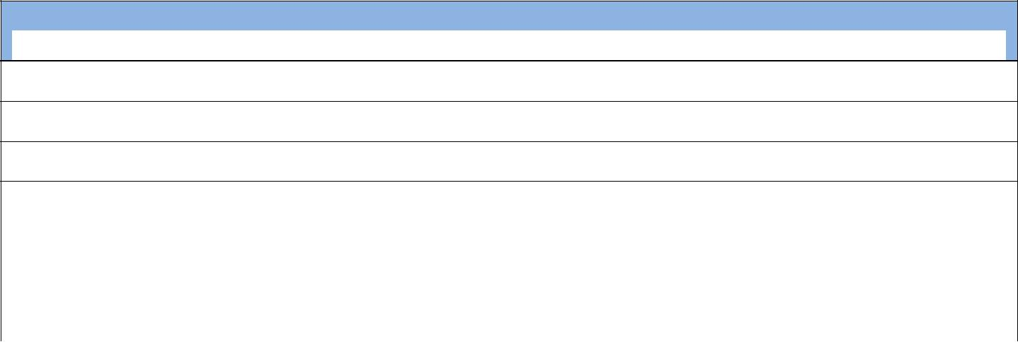
Concept 1: Researching Tools
Students will:

B 1. Access a website that is bookmarked or linked

B 2. Launch a web browser, enter web address and access the information

B 3. Gather information using appropriate internet resources

B 4 Use search engines effectively to locate information

B 5. Locate and analyze technology resources to complete a specific task

B 6 Evaluate the information of Internet reference sources

B 7. Discuss and respect ownership of resources

7

Technology Standards Articulation
Third Grade

STRAND 6: Technological Critical Thinking, Problem Solving, and Decision Making

Every student will use critical thinking skills to plan and conduct research, manage projects, solve problems and make informed decisions using appropriate digital tools and resources.
Concept 1: Critical Thinking
Students will:

B 1. Understand how technology impacts their daily life

B 2. Research a topic and identify a problem, with teacher guidance

Concept 2: Problem Solving
Students will:

B 1. Follow and manage activities to develop a solution or complete a project

B 2. With teacher assistance collect data to identify solutions. With teachers assistance, students are able to make informed decisions

Concept 3: Decision Making
Students will:

B 1. Use technology tools and resources provided to address a variety of tasks and problems

B 2. Use multiple processes to explore alternative solutions

8

